Warm and Special Thank you! – Words cannot express the gratitude that I have for those individuals who helped make Men’s Day as success. I’d like to personally thank each and every person who participated in Men’s Day, those that contributed financially, physically and through prayer. In particular: Pastor Hamilton, Pastor Jackson, Bro. Shepherd, Marchanon, Kelsey, and Kameron Bunn, Earl, Erroll, Nicole, Kailyn and Kelley Dunson, Roselyn Duncan, Ann Ross, Darlene Thomas, Annie Jennings, Kay and Kayron Denham, D’Joane McCorkle, Jason Harris, Jessica and Lance Willis, Hanna Cosby, Zina King, Mike Warren Jr, Drake Barber, Mr. and Mrs. Pouncey, Joan Kuykendall, and Maxine Kelly. Each of you hold a special place in my heart. Without God along with your help, the day would not have been possible. Many blessings to each of you for your support and dedication.
- Kind regards, Kellye Richardson

South Atlantic Conference Mental Health Conference “I Am Mental Health: Do You See Me?” is coming August 25th – 27th at the camp ground! Go online to register at www.adventsource.org. Early bird special deadline is July 5th and registration ends August 8th! Call the office at 404-792-0535, ext. 111 to reserve housing (separate cost) with Marlene Edwards.

For additional information, contact Rosemary Graham at 404-792-0535, ext. 503

Special Announcement - If you or a loved one is suffering from an addiction to drugs, alcohol, and other mind-altering substances, then please come and receive Spiritual guidance on how to regain your freedom to overcome the habit. We meet at 7 PM, every 1st and 3rd Friday of each month in the chapel of the Berean SDA Church. 291 H.E. Holmes Dr. Atlanta, GA 30318 404 799 - 7288. All are welcome to attend!

Women’s Ministry – Ladies, we hope that you are enjoying the study and many blessings received during this 40 Days of Prayer and Devotion. A culmination event/group discussion is forth coming. May God richly bless each of you.
Meetings & Reminders

Sabbath:
- Early Morning Prayer Service at 8:45am
- Trailblazers Pathfinder every 1st Sabbath in Fellowship Hall
- AYS Program every 2nd, 3rd, and 4th Sabbath

Sunday:
- Trailblazers Pathfinder every 3rd Sunday in Fellowship Hall
- Adventurers Meetings
Every 1st and 3rd Sundays, 10am-1pm.

Tuesday/Wednesday:
- Bulletin submissions due by 8pm.
Email Sister Kelli Duncan at mtolivechurchassist@gmail.com
- Email Newsletter (News from The Mount)
Submit to info@mtolivesda.com by Wednesday, 12 noon

Wednesday:
- Mid-Week Prayer Service from 7 - 8 pm.

Pastoral Staff

Lawrence Hamilton , Pastor 770 597-5981
Gerald Helton, First Elder 404 502-6481
Lance Willis, Head Deacon 718 664-5631
Annie Jennings, Head Deaconess 770 969-2369
Lunie Stephens, Church Clerk 678 408-0967
Jerome Gallon, General Sabbath School Supt. 404 573-3411
John Clark, Community Services Director 404 798-0287
Jerome Gallon, Personal Min. Dir. 404 573-3411
Jason Harris, Treasurer 404 723-2999
Drake Barber, Church Admin 470-774-0068

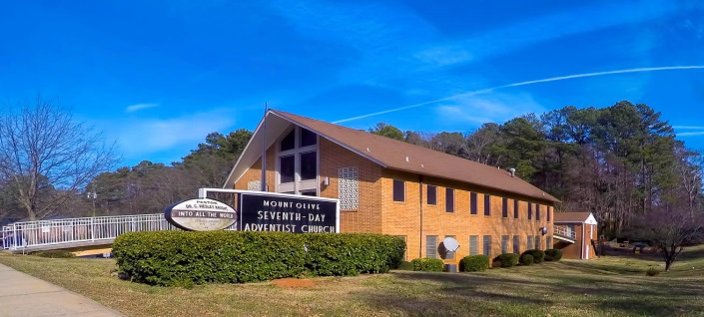
Mt. Olive
SDA Church

Pastor Lawrence Hamilton

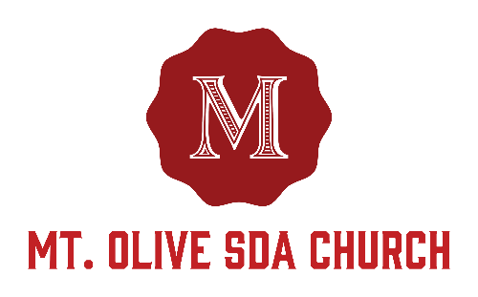

3366 Mt. Olive Road
East Point, GA 30344
404-228-9182
www.mtolivesda.com

July 1, 2017

Our Mission:

Proclaim the Good News

Lead Others to Christ

Unite Others with His Church

Prepare for Christ’s Return

Welcome Visitors!

The Mt. Olive Church family is so delighted to have you in our midst today! May you receive the blessings of the Holy Spirit. Please come again to worship with us.

Let’s be a church that studies God’s Word!

General Information

On Duty Today
Church Clerk: Sister Lunie Stephens
Music/Worship Coordinator: Sim Stevenson
Prayer Request Coordinator: Sister Lydia Cole,
770-774-1434

Online Giving - Return your tithes and offerings online using the Adventist Giving Program, which can be accessed via our website: http://mtolivesda.com/


Sunset Today 8:52 pm
Sunset Next Friday 8:51 pm

Sick and Shut In

Please remember our sick and shut in members in prayer. Give them a call to let them know you care.

Sister Hazel Jackson 404-474-2337
Sister Louise Dunson 404-524-2720
Sister Willie Pearl Williams 770-808-6921
Sister Patricia Hilliary 404-766-1173
Brother Arthur P. Meadows 404-762-5958
Sister Kathleen Albert 770-695-3927
Ann Williams

Sabbath School
9:15 am
Superintendent: Jerome Gallon
Opening Song
Scripture & Prayer
Welcome
Mission Emphasis
Teacher’s Prayer
Lesson Study
Closing Remarks & Prayer

Personal Ministries / Departmental Announcements
11:20 – 11:30 am

Divine Worship Service
11:30 am
Introit Praise Team

Scripture Reading Elder Erroll Dunson

Opening Prayer Elder Erroll Dunson

Welcome Elder Erroll Dunson

Children’s Story Elder Leroy Thomas

Hymn of Praise Brother Calvin Manley

Intercessory Prayer Elder Estella Lain

Tithes & Offerings Elder Estella Lain

Praise and Worship Praise Team

Sermon Pastor Lawrence Hamilton

Closing Pastor Lawrence Hamilton

Announcements
AYS Department – Thank you for all who made it out to Friday Night Live last week!! We are most grateful for the Lord’s presence and the wonderful responses we have been getting from our youth! We look forward to doing more programs like this in the future. Until then, please be sure to join us next week for another spirit filled AYS program.

SPECIAL PROGRAM: TEEN ISSUES
Join us on July 8th at 5 pm in the sanctuary for a safe and unfiltered discussion of the issues our teens face every day with special guest Pastor Donovan Washington and featured act Cadence. Also, please come out to show your support for our youth as we help them prepare for Christ’s return.

Family Life - We all have a place in Mt. Olive's Family Life Ministry!!!

Family Ministries focuses on the family as a whole and on each individual that comprises the unit. It focuses on strengthening the relationships between the individuals in the family -- the relationship that connects husband and wife in marriage, parent and child in a unique parent-child bond, family to family in the community of faith and in the wider society. Each individual is essential to the effective functioning of the family.

If you're interested in serving our church family, please contact Brother Paul Seal or Sister Linda Seal at 404-629-1055. FYI, we need youth involvement: teens, young adults and the young at heart!

Men’s Ministry – We would like to thank the Women's Ministry Department for a job well done. Ladies, we appreciate the care that the men receive on Men Ministry Day. We thank you for the time you spared and the helping hand you gave. It meant so much and we thank the Lord for the effort that you made.
- Bro. Brian Shepard Sr., Men’s Ministry Leader

